**WEEK-6**

**1)** **APP.JS**

import logo from './logo.svg';

import './App.css';

function App() {

  return (

    <center>

    <h1>Welcome the first session of react</h1>

    </center>

  );

}

export default App;

**OUTPUT:**

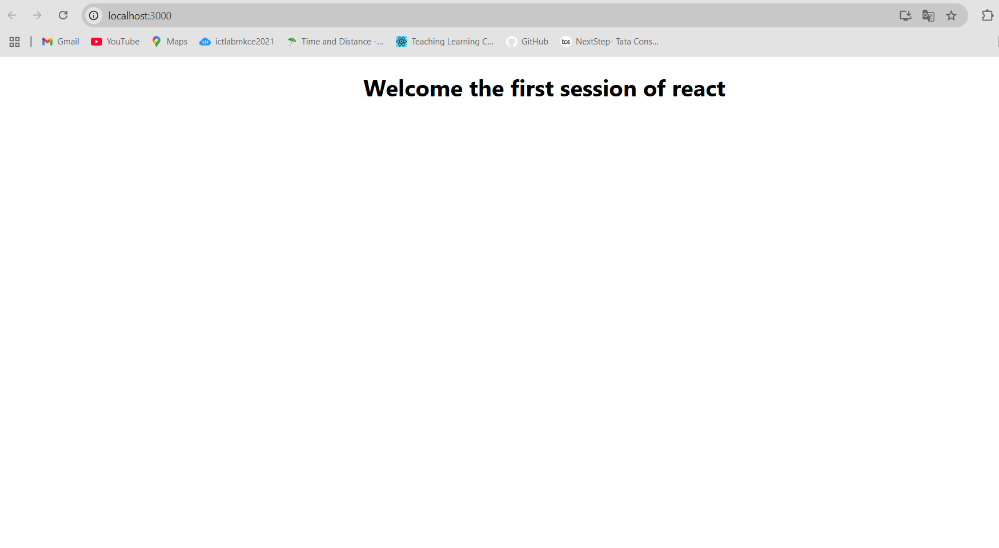

**2)App.js**

import React from 'react';

import Home from './Home';

import About from './About';

import Contact from './Contact';

function App() {

  return (

    <div>

      <Home />

      <About />

      <Contact />

    </div>

  );

}

export default App**;**

**Contact.js**

import React from 'react';

function Contact() {

  return (

    <h2 style={{ textAlign: 'center' }}>

      Welcome to the Contact Page of Student Management Portal

    </h2>

  );

}

export default Contact;

**Home.js**

import React from 'react';

function Home() {

  return (

    <h2 style={{ textAlign: 'center' }}>

      Welcome to the Home Page of Student Management Portal

    </h2>

  );

}

export default Home;

**About.js**

import React from 'react';

function About() {

  return (

    <h2 style={{ textAlign: 'center' }}>

      Welcome to the About Page of Student Management Portal

    </h2>

  );

}

export default About;

**OUTPUT:**

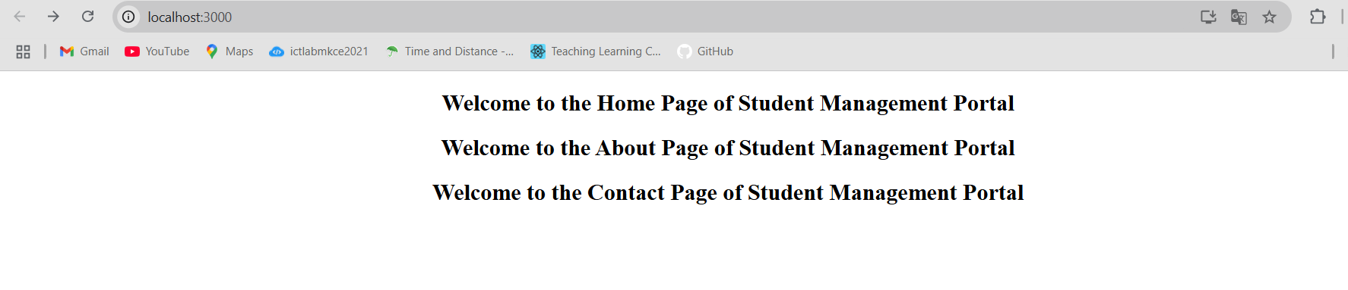

**3)App.js**

import { CalculateScore } from './CalculateScore';

function App() {

  return (

    <div>

      <CalculateScore

        Name="Steeve"

        School="DNV Public School"

        total={284}

        goal={3}

      />

    </div>

  );

}

export default App;

**CalculateScore.js**

import './mystyle.css';

const percentToDecimal = (decimal) => {

  return decimal.toFixed(2) + '%';

};

const calcScore = (total, goal) => {

  return percentToDecimal(total / goal);

};

export const CalculateScore = ({ Name, School, total, goal }) => {

  return (

    <div className="formatstyle">

      <h1><font color="brown">Student Details:</font></h1>

      <div className="Name">

        <b><span>Name: </span></b>

        <span>{Name}</span>

      </div>

      <div className="School">

        <b><span>School: </span></b>

        <span>{School}</span>

      </div>

      <div className="Total">

        <b><span>Total: </span></b>

        <span>{total}</span>

        <span>Marks</span>

      </div>

      <div className="Score">

        <b>Score:</b>

        <span>{calcScore(total, goal)}</span>

      </div>

    </div>

  );

};

**Mystyle.css**

.Name {

  font-weight: 300;

  color: blue;

}

.School {

  color: crimson;

}

.Total {

  color: darkmagenta;

}

.formatstyle {

  text-align: center;

  font-size: large;

}

.Score {

  color: forestgreen;

}

**OUTPUT:**

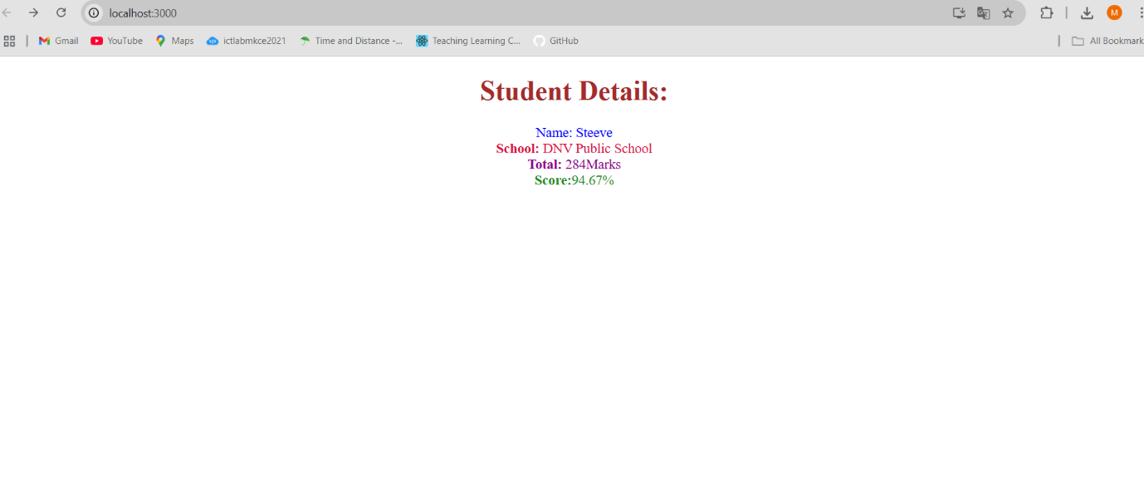

**4)App.js**

// src/App.js

import React from 'react';

import Posts from './Posts';

function App() {

  return (

    <div className="App">

      <Posts />

    </div>

  );

}

export default App;

**Posts.js**

// src/Posts.js

import React from 'react';

import Post from './Post';

class Posts extends React.Component {

constructor(props) {

super(props);

this.state = {

posts: [],

error: null

};

}

loadPosts() {

fetch('https://jsonplaceholder.typicode.com/posts')

.then(response => response.json())

.then(data => {

const postList = data.map(post => new Post(post.id, post.title, post.body));

this.setState({ posts: postList });

})

.catch(error => {

this.setState({ error: error.message });

});

}

componentDidMount() {

this.loadPosts();

}

componentDidCatch(error, info) {

alert("An error occurred: " + error.toString());

}

render() {

return (

<div>

<h1>Blog Posts</h1>

{this.state.error && <p style={{ color: 'red' }}>{this.state.error}</p>}

{this.state.posts.map(post => (

<div key={post.id}>

<h2>{post.title}</h2>

<p>{post.body}</p>

</div>

))}

</div>

);

}

}

export default Posts;

**Post.js**

// src/Post.js

class Post {

constructor(id, title, body) {

this.id = id;

this.title = title;

this.body = body;

}

}

export default Post;

**OUTPUT:**

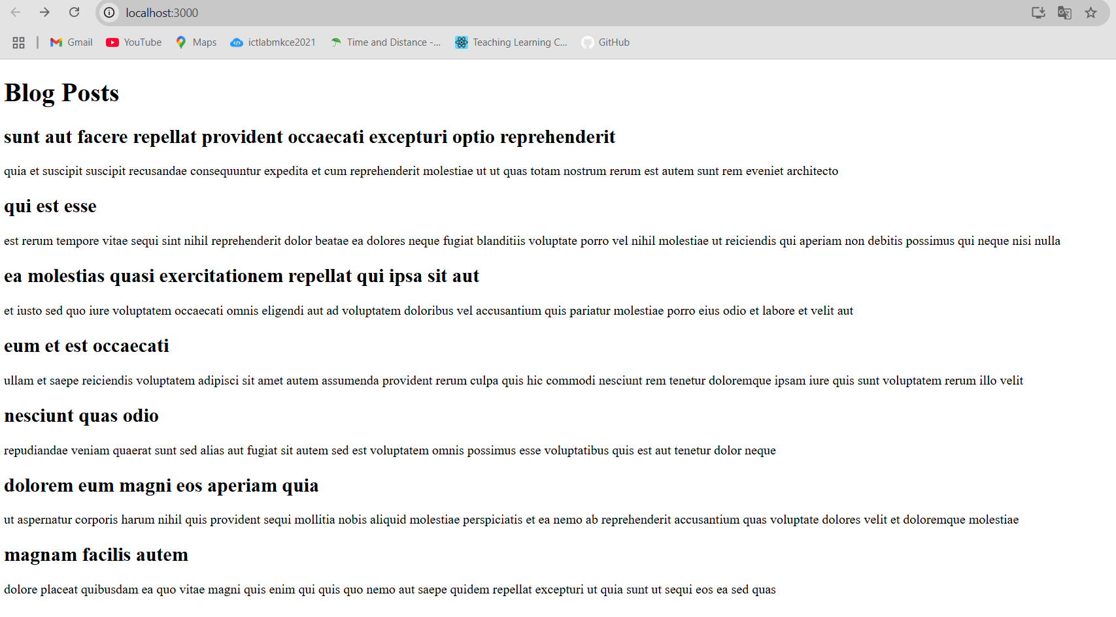

**5)App.js**

import React from "react";

import "./mystyle.css"; // import your stylesheet here

function App() {

  const cohorts = [

    {

      name: "INDAWT010 - .NET FSD",

      startDate: "02-Aug-2021",

      endDate: "03-Sep-2021",

      currentStatus: "Scheduled",

      status: "other"

    },

    {

      name: "ADMEXF1014 - Java FSD",

      startDate: "02-Sep-2021",

      endDate: "03-Oct-2021",

      currentStatus: "Ongoing",

      status: "ongoing"

    },

    {

      name: "CBDFR1025 - Java FSD",

      startDate: "02-Oct-2021",

      endDate: "03-Nov-2021",

      currentStatus: "Completed",

      status: "other"

    }

  ];

  return (

    <div>

      <h2>Cohorts Details</h2>

      {cohorts.map((cohort, index) => (

        <div key={index} className="box">

          <h3 className={cohort.status === "ongoing" ? "green" : "blue"}>

            {cohort.name}

          </h3>

          <h4>Start Date: {cohort.startDate}</h4>

          <h4>End Date: {cohort.endDate}</h4>

          <h4>Current Status: {cohort.currentStatus}</h4>

        </div>

      ))}

    </div>

  );

}

export default App;

**mystyle.css**

.box {

  width: 300px;

  display: inline-block;

  margin: 10px;

  padding: 10px 20px;

  border: 1px solid black;

  border-radius: 10px;

}

h4 {

  font-weight: 500;

}

.green {

  color: green;

}

.blue {

  color: blue;

}

**OUTPUT:**

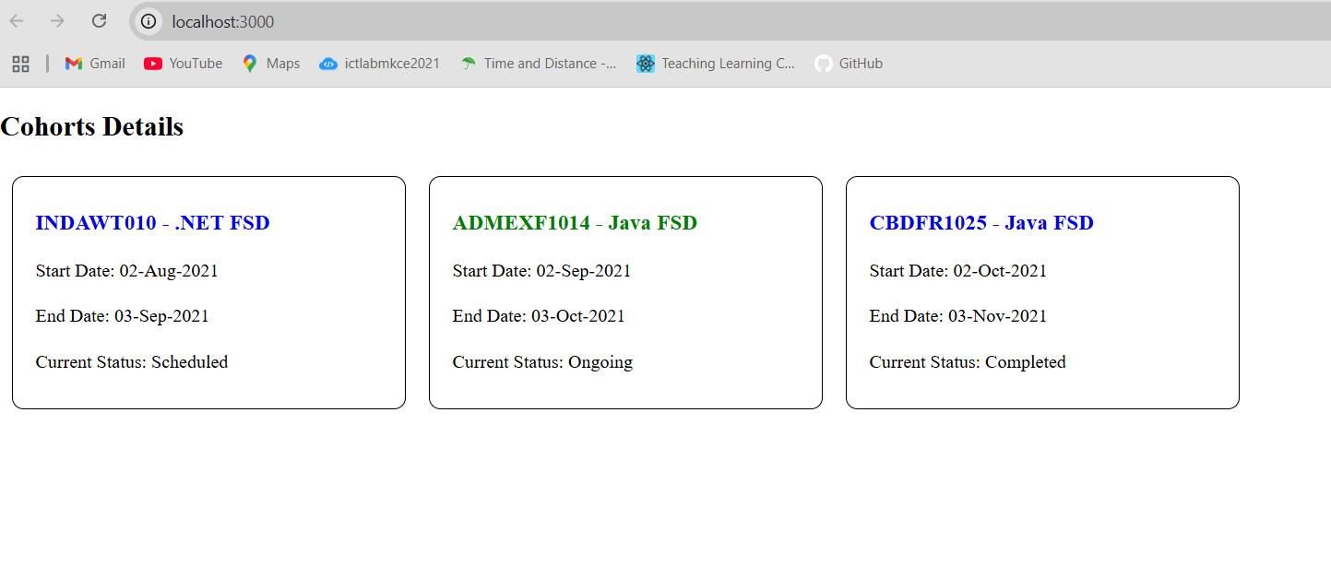

**6)App.js**

import { BrowserRouter, Routes, Route, Link } from "react-router-dom";

import Home from "./Home";

import TrainerList from "./TrainerList";

import TrainerDetail from "./TrainerDetail";

function App() {

  return (

    <BrowserRouter>

      <div>

        <h1>My Academy Trainers App</h1>

        <nav>

          <Link to="/">Home</Link> | <Link to="/trainers">Show Trainers</Link>

        </nav>

        <Routes>

          <Route path="/" element={<Home />} />

          <Route path="/trainers" element={<TrainerList />} />

          <Route path="/trainers/:id" element={<TrainerDetail />} />

        </Routes>

      </div>

    </BrowserRouter>

  );

}

export default App;

**Trainer.js**

class Trainer {

  constructor(trainerId, name, email, phone, technology, skills) {

    this.trainerId = trainerId;

    this.name = name;

    this.email = email;

    this.phone = phone;

    this.technology = technology;

    this.skills = skills;

  }

}

export default Trainer;

**TrainerDetail.js**

import { useParams } from "react-router-dom";

import trainersMock from "./TrainersMock";

function TrainerDetail() {

  const { id } = useParams();

  const trainer = trainersMock.find((t) => t.trainerId === id);

  if (!trainer) return <p>Trainer not found</p>;

  return (

    <div>

      <h2>Trainers Details</h2>

      <p>

        <strong>{trainer.name} ({trainer.technology})</strong>

      </p>

      <p>{trainer.email}</p>

      <p>{trainer.phone}</p>

      <ul>

        {trainer.skills.map((skill, index) => (

          <li key={index}>{skill}</li>

        ))}

      </ul>

    </div>

  );

}

export default TrainerDetail;

**TrainerList.js**

import { Link } from "react-router-dom";

import trainersMock from "./TrainersMock";

function TrainerList() {

  return (

    <div>

      <h2>Trainers List</h2>

      <ul>

        {trainersMock.map((trainer) => (

          <li key={trainer.trainerId}>

            <Link to={`/trainers/${trainer.trainerId}`}>{trainer.name}</Link>

          </li>

        ))}

      </ul>

    </div>

  );

}

export default TrainerList;

**Trainermock.js**

import Trainer from "./Trainer";

const trainersMock = [

  new Trainer(

    "t-syed8",

    "Syed Khaleelullah",

    "khaleelullah@cognizant.com",

    "97676516962",

    ".NET",

    ["C#", "SQL Server", "React", ".NET Core"]

  ),

  new Trainer(

    "t-jojo",

    "Jojo Jose",

    "jojo@cognizant.com",

    "9897199231",

    "Java",

    ["Java", "JSP", "Angular", "Spring"]

  ),

  new Trainer(

    "t-elisa",

    "Elisa Jones",

    "elisa@cognizant.com",

    "9871212235",

    "Python",

    ["Python", "Django", "Angular"]

  )

];

export default trainersMock;

**OUTPUT:** 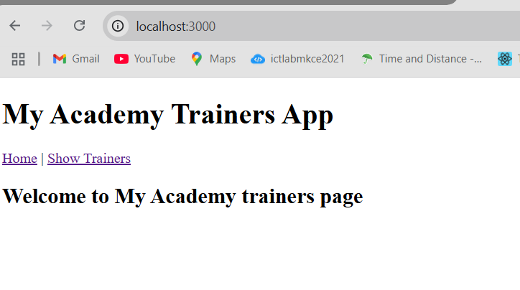

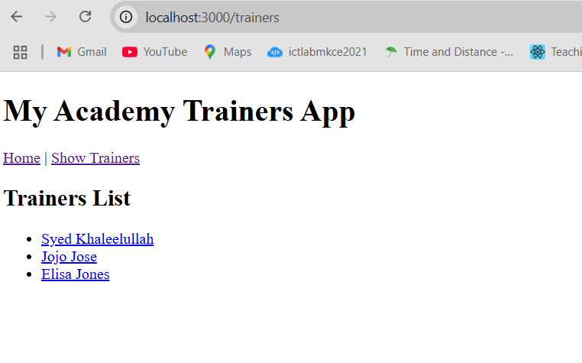

**7)App.js**

import React from "react";

import OnlineShopping from "./OnlineShopping";

function App() {

  return (

    <div className="App">

      <OnlineShopping />

    </div>

  );

}

export default App;

**Cart.js**

import React from "react";

function Cart(props) {

return (

<table border="1" cellPadding="10" align="center">

<thead>

<tr>

<th>Name</th>

<th>Price</th>

</tr>

</thead>

<tbody>

{props.item.map((item, index) => (

<tr key={index}>

<td>{item.itemname}</td>

<td>{item.price}</td>

</tr>

))}

</tbody>

</table>

);

}

export default Cart;

**OnlineShopping.js**

import React, { Component } from "react";

import Cart from "./Cart";

export default class OnlineShopping extends Component {

render() {

const CartInfo = [

{ itemname: "Laptop", price: 80000 },

{ itemname: "TV", price: 120000 },

{ itemname: "Washing Machine", price: 50000 },

{ itemname: "Mobile", price: 30000 },

{ itemname: "Fridge", price: 70000 },

];

return (

<div className="mydiv" style={{ textAlign: "center" }}>

<h1 style={{ color: "green" }}>Items Ordered :</h1>

<Cart item={CartInfo} />

</div>

);

}

}

**OUTPUT:**

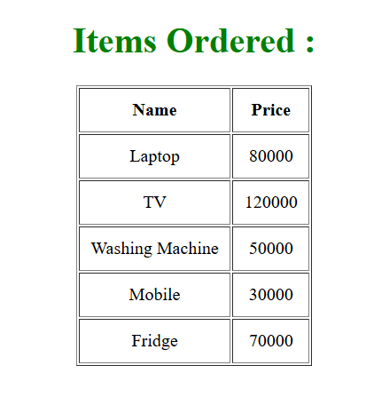

**8)** **CountPeople.js**

import React, { Component } from "react";

class CountPeople extends Component {

  constructor() {

    super();

    this.state = {

      entrycount: 0,

      exitcount: 0

    };

  }

  updateEntry() {

    this.setState((prevState) => ({

      entrycount: prevState.entrycount + 1

    }));

  }

  updateExit() {

    this.setState((prevState) => ({

      exitcount: prevState.exitcount + 1

    }));

  }

  render() {

    return (

      <div style={{ textAlign: "center", marginTop: "50px" }}>

        <button

          onClick={() => this.updateEntry()}

          style={{ backgroundColor: "lightgreen", marginRight: "20px" }}

        >

          Login

        </button>

        <span style={{ marginRight: "50px" }}>

          {this.state.entrycount} People Entered!!!

        </span>

        <button

          onClick={() => this.updateExit()}

          style={{ backgroundColor: "lightgreen" }}

        >

          Exit

        </button>

        <span style={{ marginLeft: "20px" }}>

          {this.state.exitcount} People Left!!!

        </span>

      </div>

    );

  }

}

export default CountPeople;

**App.js**

import React from "react";

import CountPeople from "./CountPeople";

function App() {

  return (

    <div className="App">

      <CountPeople />

    </div>

  );

}

export default App;

**OUTPUT:**

